**Date:** 8/12/2022

# 7. LCD DISPLAY IMNTERFACING

**AIM:** Write an Assembly Language Program to interface LCD screen and display the text

**TOOLS REQUIRED:** PC, Keil µvision5, Atmel Flip software, MC module

# PROCEDURE:

1. Turn on the computer, create a folder on D drive saved with Register Number.
2. Open Keil uVision5 in desktop, or windows start menu → all programs → open Keil uVision5.
3. Create a project with AT89C51ED2.
4. Write a program in keil uVision 5with an extension .asm
5. Right click on target folder 🡪 select options 🡪 select the output tab 🡪 check the create hex file option.
6. Build the target to check any error and to build the hex file.

# Interfacing With hardware:

1. Open the Device manager form the start menu → Select the ports tab → See which port is interfacing with the MC module.
2. Open the Atmel Flip software → Select the AT89C51ED2 to interface → select the port and standard baud rate → select the serial communication channel (RS232).
3. Press the reset button in MC module → click on file and upload the hex file into the MC by setting it in programming mode.
4. After hex file is uploaded, run the test for verification by clicking run option.
5. Now set the mode to execution mode by setting the switch in to execution mode
6. Click the reset button, now the text is displayed in the LCD display which you written in the code file.

**HARDWARE INTERFACING:**

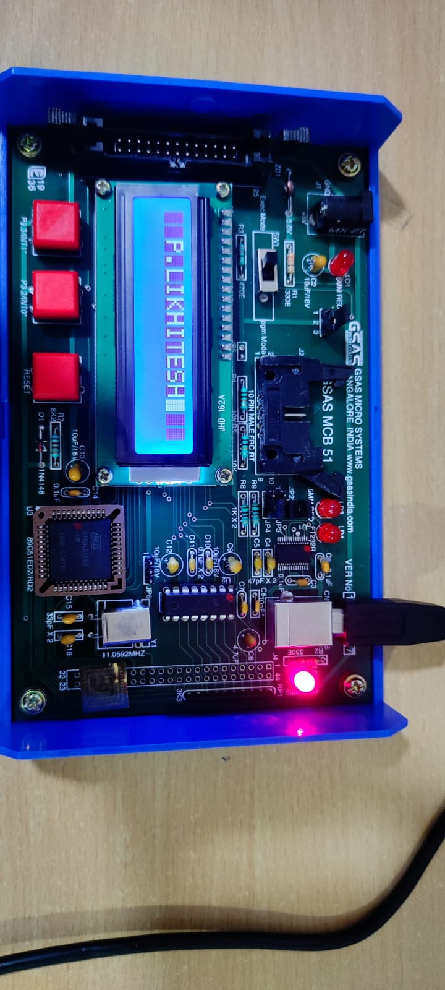

**LCD INSTRUCTIONS:**

|  |  |  |  |
| --- | --- | --- | --- |
| **S.No** | **Instructions** | **Hex** | **Decimal** |
| 1 | Function set: 8-bit, 1 Line, 5x7 Dots | 0x30 | 48 |
| 2 | Function set: 8-bit, 2 Line, 5x7 Dots | 0x38 | 56 |
| 3 | Function set: 4-bit, 1 Line, 5x7 Dots | 0x20 | 32 |
| 4 | Function set: 4-bit, 2 Line, 5x7 Dots | 0x28 | 40 |
| 5 | Entry Mode | 0x06 | 6 |
| 6 | Display off Cursor off (clearing display without clearing DDRAM content) | 0x08 | 8 |
| 7 | Display on Cursor on | 0x0E | 14 |
| 8 | Display on cursor off | 0x0C | 12 |
| 9 | Display on Cursor Blinking | 0x0F | 15 |
| 10 | Shift entire display left | 0x18 | 24 |
| 11 | Shift entire display right | 0x1C | 30 |
| 12 | Move cursor left by one character | 0x10 | 16 |
| 13 | Move cursor right by one character | 0x14 | 20 |
| 14 | Clear Display (also clear DDRAM content) | 0x01 | 1 |

# PROGRAM:

|  |  |  |  |  |
| --- | --- | --- | --- | --- |
| **ADDRESS** | **OPCODES** | **LABELS** | **MNEMOICS** | **OPERANDS** |
| 0400 |  |  | ORG | 0400H |
| 0400 | 502E4C49 |  | DB | "P.LIKHITESH",0 |
| 0000 |  |  | ORG | 00H |
| 0000 | 900400 |  | MOV | DPTR, #0400H |
| 0003 | 7438 |  | MOV | A, #38H |
| 0005 | 1124 |  | ACALL | CMD |
| 0007 | 7401 |  | MOV | A, #01H |
| 0009 | 1124 |  | ACALL | CMD |
| 000B | 740F |  | MOV | A, #0FH |
| 000D | 1124 |  | ACALL | CMD |
| 000F | 7406 |  | MOV | A, #06H |
| 0011 | 1124 |  | ACALL | CMD |
| 0013 | 7482 |  | MOV | A, #82H |
| 0015 | 1124 |  | ACALL | CMD |
| 0017 | 7F0B |  | MOV | R7, #0BH |
| 0019 | 7800 |  | MOV | R0, #00H |
| 001B | E8 | BACK: | MOV | A,R0 |
| 001C | 93 |  | MOVC | A, @A+DPTR |
| 001D | 1131 |  | ACALL | INFO |
| 001F | 08 |  | INC | R0 |
| 0020 | DFF9 |  | DJNZ | R7, BACK |
| 0022 | 80FE |  | SJMP | $ |
| 0024 | C2B7 | CMD: | CLR | P3.7 |
| 0026 | C2B6 |  | CLR | P3.6 |
| 0028 | F5A0 |  | MOV | P2, A |
| 002A | D2B5 |  | SETB | P3.5 |
| 002C | C2B5 |  | CLR | P3.5 |
| 002E | 113E |  | ACALL | DELAY |
| 0030 | 22 |  | RET |  |
| 0031 | D2B7 | INFO: | SETB | P3.7 |
| 0033 | C2B6 |  | CLR | P3.6 |
| 0035 | F5A0 |  | MOV | P2, A |
| 0037 | D2B5 |  | SETB | P3.5 |
| 0039 | C2B5 |  | CLR | P3.5 |
| 003B | 113E |  | ACALL | DELAY |
| 003D | 22 |  | RET |  |
| 003E | 79FF | DELAY: | MOV | R1, #0FFH |
| 0040 | 7AFF | WAIT: | MOV | R2, #255 |
| 0042 | DAFE |  | DJNZ | R2, $ |
| 0044 | D9FA |  | DJNZ | R1, WAIT |
| 0046 | 22 |  | RET |  |
|  |  |  | END |  |

**RESULT:** Given text is displayed successfully in the LCD display